Tessella Project Number: 6870
Tessella plc 26 The Quadrant, Abingdon Science Park, Abingdon, Oxfordshire, OX14 3YS, UK
T: +44 (0)1235 555511 | F: +44 (0)1235 553301 | E: info@tessella.com | www.tessella.com

Client: STFC & ORNL
Mantid
PM report to Project Management Board
21st October 2011



Document Control
This document is under document control. All members of the distribution list will receive updated copies whenever alterations are made. All other copies are uncontrolled.

Contributors
Name | Role | Company
Nicholas Draper | Author | Tessella

Document Approval
Name | Role | Company

Distribution
Name | Role | Company
Project Management Board Members | Recipient | STFC
Mantid Project Repository | Filing | STFC

Revision History
Author | Issue | Date | Description
Nicholas Draper | V1.R1.M0 | 12-Oct-2011 | 1st version written

References
Document | Ref | Date | Details and Version
Short, Medium and long term requirements from ISIS Instrument groups | [SML REQ]] | 04-Aug-2009 | http://svn.mantidproject.org/mantid/trunk/Documents/Requirements/ShortMedLong%20Aug%2009.xls
Project Specification | [PS] |  | http://svn.mantidproject.org/mantid/trunk/Documents/Project%20Management/ProjectSpecification.doc
Stakeholder Plan | [SP] |  | http://svn.mantidproject.org/mantid/trunk/Documents/Project%20Management/StakeholderPlan.doc
Risk Register | [RR] |  | http://svn.mantidproject.org/mantid/trunk/Documents/Project%20Management/RiskRegister.xls

Table of Contents
1 Introduction 4
1.1 Purpose of this Document 4
1.2 Scope of this Document 4
1.3 Context of this Issue 4
2 Project Documentation 4
3 Project Status 4
3.1 Development Progress 4
4 Project Management Issues 6
4.1 Mantid supported environments – specifically withdrawing support for RHE5 6
4.2 ISIS project management committee 6
5 Sansview and Mantid 6
6 Mantid version 2.0 6
7 Scientist Jamboree 6
8 NOBUGS 2012 & Mantid workshop 6
9 Supporting Mantid 7
9.1 Current Process 7
10 Financial review 7
11 Future Release Dates 7
12 Collaborating With Other Facilities 8
12.1 Interest from other institutions 8
12.2 Current Collaboration Strategy 8
13 Appendix 9
13.1 Project Metrics 9
13.2 Ticket completion rate 9
13.3 Project Uptake 11

Introduction

Purpose of this Document
This report details the current state of the Mantid project and summarises the current plans for further development. The project management board will use the information in this report as a basis for the meeting.

Scope of this Document
The scope of this document is limited to the Mantid project, both for progress up to the meeting of the Project management board, and plans for the future.

Context of this Issue
This is the sixth project management report to the Mantid project management board and will provide input to the sixth meeting.

Project Documentation
The project documentation is available through the links below. The Risk Register has been reviewed and three additional risks added. The other documents have not been changed since the last PMB meeting.
- Stakeholder Plan:
http://svn.mantidproject.org/mantid/trunk/Documents/Project%20Management/StakeholderPlan.doc
- Risk Register:
http://svn.mantidproject.org/mantid/trunk/Documents/Project%20Management/RiskRegister.xls

Project Status

Development Progress
Since the last PMB meeting in May 2011 we have completed two development iterations and released new versions of Mantid on the following dates:
- 1st July 2011
- 23rd September 2011
The rate of development within Mantid continued at a fast pace for these two releases; this is supported the project metrics in section 13.2. In particular we have made significant improvements to (among many others):
- The Long term support version of Ubuntu is now fully supported within Mantid and a repository is provided to download Mantid and perform updates.
- Transferred the source code control to a distributed versnio control system, with the central replica at GitHub, and will have replicas at both facilities.
- Various improvements to the user interface and usability
  - A new Interactive masking tab in the instrument display
  - Improved interaction with table workspaces
  - Waterfall plots
  - Algorithm category hiding
- Model fitting improvements
  - Usability redesign, allowing more setups to be stored and reused and greater control of the display of results.
  - First implementation of simultaneous fitting of multiple datasets.
- The core of the analysis of SANS data has been rewritten and validated, it improves the results with low statistics
- Initial support for event data at ISIS for WISH, SANS2D and LET. Mantid can now read and manage monitor data as events as well as histograms.
- Dramatically improved the loading performance of event nexus and prenexus files.
- First releases of VATES
  - Peak finding, UB matrix determination
  - Multidimensional data workspaces, offline data storage, merging workspaces, saving and loading from multiple formats
  - Rebinning both axis-aligned or non-axis-aligned
  - Two display interfaces, Mantidplot and Paraview:
    - Histogram and event plots of multidimensional data
    - Box glyph overlays of detected peaks.
    - Interactive slicing and rebinning tools

Current Development team
ISIS | SNS
Nicholas Draper (Tessella, PM) | Stuart Campbell (SNS)
Martyn Gigg (Tessella) | Peter Peterson (SNS)
Roman Tolchenov (Tessella) | Mathieu Doucet (SNS)
Owen Arnold (Tessella) | Russell Taylor (Tessella)
Karl Palmen (STFC) | Janik Zikovsky (SNS)
Anders Markvardsen (70%, STFC) | Michael Reuter (SNS)
Alex Buts (50%, STFC) | Andre Savici (SNS)
Ronald Fowler (0% eScience) | Vickie Lynch (SNS)
Robert Whitely (STFC) | Dennis/Ruth Mikkleson (SNS, Part time)
Peter Parker (STFC) | Wenduo Zhuo (SNS)
 | Shelly Ren (SNS)
 | Jean Bilheaux (SNS)
Since the last PMB meeting, the ISIS team has changed significantly, two members of staff have left the team and three new ones have joined. This has naturally resulted in an overall reduction on the capacity of the ISIS team while we have been training the new members of staff on the project. However the new members of the team are now beginning to be productive.
Over the last few months we have chosen to reduce the amount of Ron Fowlers time on the project until the VATES project is closer to being ready for progression on quantitative analysis. He will rejoin the project on a full time basis in November.
An offer has been made for a postdoc in the to support inelastic data reduction in the SNS team, and two openings are being progressing at ISIS.

Project Management Issues

Mantid supported environments – specifically withdrawing support for RHE5
It has become apparent the both facilities have successfully migrated several systems to RHE6, but several RHE5 systems remain. The technologies supported in RHE5 are increasing old, and cannot support some of the developments we are planning such as the adoption of iPython as a scripting interface. I would like to discuss a potential timetable for the withdrawal of support for RHE5.

ISIS project management committee
At ISIS we have implemented a project management committee to discuss issues specific to ISIS including resourcing as well as local priorities. This simply formalizes the ad hoc conversations that previously occurred in peoples offices. The meeting is attended by:
- Toby Perring
- Sean Langridge
- Jon Taylor
- Freddie Akeroyd
- Debbie Greenfield
- Nick Draper

Sansview and Mantid
We have requirements to support SANS model fitting at both facilities, and it appears that the SANSView package by Paul Butlers team will provide the most efficient way of supporting those requirements. While the package is quite functionally capable I would anticipate we would still have to devote a significant effort to add any missing capabilities that are required at ISIS or the SNS. We have already some resource (roughly 0.5 FTE) assigned to support the SANS fitting needs at ISIS and would extending SANSView in partnership with Paul to provide for the SANS needs. We should discuss if this is a common direction between the two possibilities and the implications of this in terms of long term support.

Mantid version 2.0
A significant change to the python scripting will be introduced in the next 3-4 months, and will require a more significant release procedure to the scientists. It makes sense to include a package of other significant improvements and release this as Mantid version 2.0. We have proposed to the ISIS scientific steering committee that we concentrate around issues to make a stable and easy to use version that scientists have verified at being capable of all the common reductions across the instruments. This will of course involve an extended testing and release process to allow the scientists to perform their validation. We have explained the ISIS aim to the SNS scientific steering committee, it may not be appropriate to go for a similar aim, but we have asked for developments they require in a similar time frame.

Scientist Jamboree
Sean Langridge has proposed a meeting of instrument scientists across both facilities to discuss data reduction and analysis issues and aims, perhaps in the joint January shutdown.

NOBUGS 2012 & Mantid workshop
The developer workshop this week has gone well and I believe is very important to ensure the close team relationships that this collaboration requires. Next years NOBUGS meeting is based at Oxford, and I think that we should plan to have the workshop for the two days at the end of the conference as we did last year when the conference was at Gatlinburg.
ISIS has offered to pay for half (or 3 whichever is lower) of the travel for US staff to attend the workshop.

Supporting Mantid

Current Process
The current process of using a shared mailing list to handle support requests no longer supports the scale of requests well, with occaisianoally multiple staff picking up the same issue simultaneously resulting in repeated work and multiple replies. We are investigating having all help requests automatically being input into our tracking system as trac tickets. This will allow us to accept tickets that we intend to answer preventing the risk of duplicated work. It will also make ithe process of transcribing tickets for development much easier and less error prone.

Financial review
Details of the project financial state is included in Appendix A and B. For ISIS the recent renewal is currently estimated to last until late 2012.
The current order for Russell Taylor at ORNL is currently estimated to end in February 2011.

Future Release Dates
Given the effort towards producing a Mantid version 2.0 I propose we extend the current iteration by removing the release planned for the 18th of November 2011, and plan for the next release to coincide with shutdown periods of both facilities.
The planned release dates for the first half of next year would be:
- 13th January 2012
- 9th March 2012
- 4th May 2012
- 6th July 2012

Collaborating With Other Facilities

Interest from other institutions

Reactor Sources

ILL
We have had no direct contact since the last PMB, but via Paul Butler’s recent visit they are still planning their 2 man year post to seriously evaluate Mantid.

Julich and HDRI
No further contact since the last PMB

ANSTO
We have been contacted about collaboration and asked to produce a first version of a data loader for their Nexus format to help their evaluation.

Pulsed Neutron sources

J-Parc
No further contact since the last PMB.

ESS
ESS visited the SNS, and through discussion with Mark Hagen again showed their interest in joining the collaboration.

Current Collaboration Strategy
The current strategy that has been approved in previous meetings of the PMB is:
- We will not explicitly encourage other institutions to adopt Mantid, but we will respond to facilities that contact us.
- In order that they may properly evaluate Mantid, we will provide assistance to create a loading routine for one format of their data, and one instrument definition.
- We explain for anyone to join the collaboration as an equal partner it would need to be agreed by the PMB, and they would need to sign a similar Memorandum of Understanding that exists between ISIS and ORNL.
- Smaller collaborations are possible, but those developments would not benefit from significant amounts of time from the development team, and would not get representation at the PMB.

Appendix

Project Metrics
SubProject | Files | Statements | %comments
Mantid Framework | 2,128 (1,897) | 272,793 (247,406) | 19.6 (18.8)
MantidPlot | 535 (545) | 96,905 (94,268)) | 13.7 (12.9)
VATES | 200 (92) | 9,338 (4,936) | 21.4 (19.2)
Total | 2,863 (2,534) | 379,036 (346,610)
The metrics are defined as follows:
Metric | Description
Files | The number of .h, and .cpp files (not including third party libraries) included in the analysis.
Statements | The number of valid C++ statements, loops, conditional statements and pre processor directives are included.
% Comments | This is the percentage of the overall number of lines which are comment lines. I have not directly reported the number of lines in the file, but a good rule of thumb is that it is roughly twice the number of statements.
The Mantid Framework code has consistently grown since the last PMB (the previous values are in brackets), as would be expected with the addition of the new functionality described in section 13.2.

Ticket completion rate
Development on Mantid is performed in two month iterations, each of which ends with an official release of the software. Longer pieces of work sometimes have to span a development iteration in which case that piece of work appears as completed only in the iterations when it becomes available to the users.
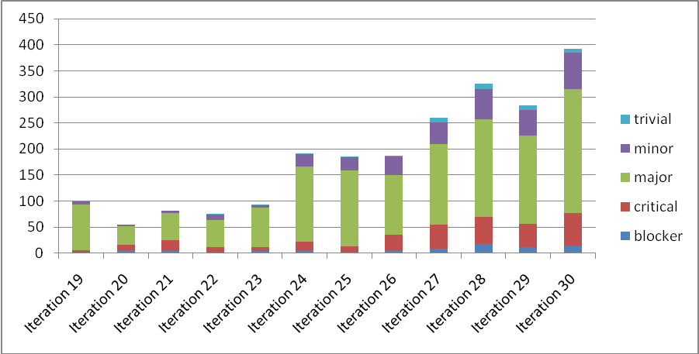

I have restricted the data to the last 12 iterations, with Iteration 29 and 30 being new since the last meeting of the PMB. The completion rate continues well, however the increase in iteration 30 is partly explained by the extended development period in that iteration.

Project Uptake

Mailing List Subscriptions
Our software download site no longer requires people to register to a mailing list in order to download the installer packages. A simple analysis of the email domains shows that while the majority of the users are from ISIS, followed by ORNL and we have had some interest from other institutions and universities.
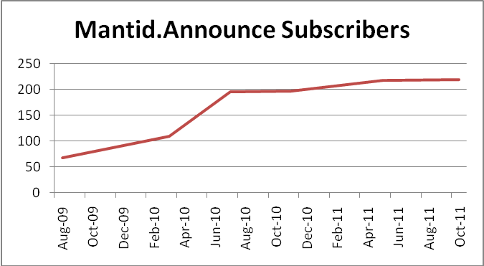
Summary
Date | Users
Aug-09 | 68
Mar-10 | 109
Jul-10 | 195
Nov-10 | 197
May-11 | 217
Oct-11 | 219

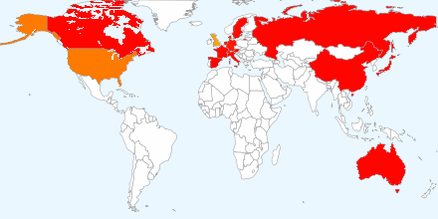
Current domain breakdown (2+ downloads)
Domain | count
stfc.ac.uk | 74
ornl.gov | 28
gmail.com | 19
helmholtz-berlin.de | 9
swansea.ac.uk | 2
caltech.edu | 2
esss.se | 2
owlpic.com | 2
tudelft.nl | 2
chem.ox.ac.uk | 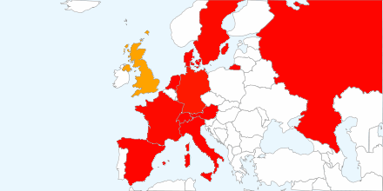  2
risoe.dtu.dk | 2
ill.fr | 2
isc.cnr.it | 2
anl.gov | 2
bath.ac.uk | 2
psi.ch | 2
uwstout.edu | 2
ansto.gov.au | 2
hmi.de | 2
j-parc.jp | 2

Software Downloads
Since December 2010 when we removed the requirement to subscribe to the mailing list, we began to track downloads. We record the ip-address along with the file downloaded, due to the nature of facility users sharing ip-addresses it is not possible to only report on unique ip-addresses, but the total count of downloads shows some interesting trends. I should also stress that this does not currently include Unix RPM downloads via the ISIS or SNS Red Hat repositories.
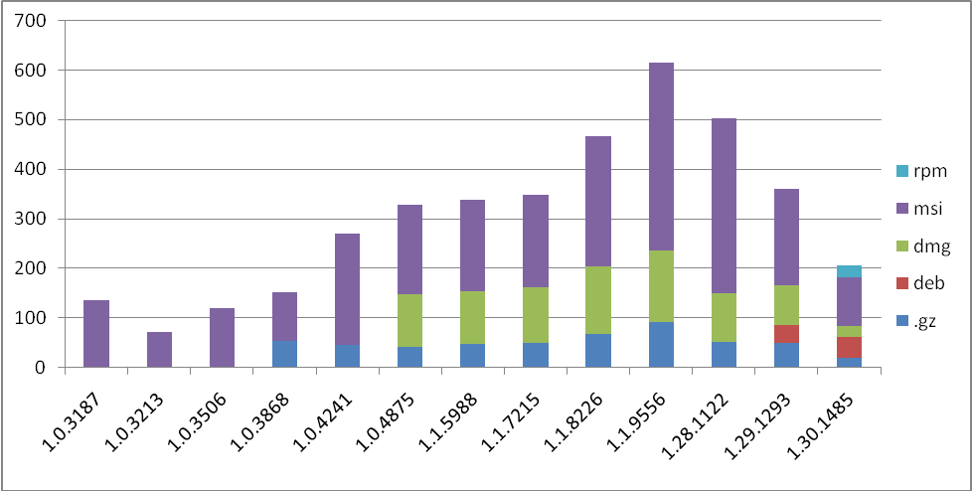

Contributing Scientists
There are several scientists that also actively contribute to the Mantid project. While there contributions are on a part time basis, often they contribute some of the best ideas.
Contributor | Contribution | Contributor | Contribution
Pascal Manuel | C++ algorithms, scripts | Jason Hodges | Python algorithms
Aziz Daoud-Aladine | Scripts, debugging support | Garrett Granroth | Scripts, debugging support
Rob Dalgleish | Reflectometry UI, Python algorithms, scripts
Tim Charlton | Python algorithms, scripts
Max Skoda | Reflectometry UI, Python algorithms, scripts
Richard Heenan | Scripts, debugging support
Stephen King | Scripts
Jon Taylor | Python Algorithms, scripts, debugging support
Stephen Cotrell | Muon C++ models, scripts
Timmy Ramirez-Cuesta | Scripts
Franz Dremmel | Scripts, debugging support
Spencer Howells | Scripts, Python Algorithms, debugging support
Several scientists have also either written or contributed to the development of instrument definitions, these include;
- Joe Kelleher
- Stephen Cottrell
- Francis Pratt
- Timothy Charlton
- Maximilian Skoda
- Matt Tucker
- Rob Dalgliesh
- Pascal Manuel.

